Waypoint Design Spec

5/1/99

Intro
We plan to control the movement of higher-level enemies in LUC with waypoints. Waypoints are similar to path_corners in that they give an enemy a prescribed path through a map. The difference with waypoints is that they will provide more “intelligence” to an enemy as this design matures.

Initial Requirements
Initially, waypoints will take on two flavors: attack and retreat.

Attack
A map designer can connect a set of attack waypoints together to form an attack path that an enemy will take when the enemy is triggered. In the picture below, the Player (P) triggers the spawning of an Enemy (E), which then follows the attack waypoints 1->2->3->4. At this point, he can engage the player. If the player is not in sight when the enemy reaches the final waypoint, the enemy will wait there until the player shows up.

An enemy following waypoints will not be affected by player noises. He won’t hunt down the player. If the enemy spots the player before reaching his final waypoint, he will stop and engage the player. If the player moves out of sight, the enemy will continue along his waypoint path to the end.

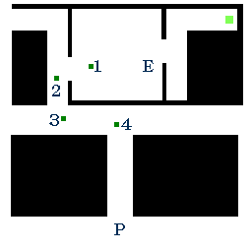

Retreat
Similar to attack waypoints, a set of retreat waypoints forms a path an enemy will take when his health gets too low. If our enemy in the example above takes too much damage, he will retreat along his retreat waypoints. In the picture below, these are 5->6->7->8.

Retreat when health is less than half maximum health. Even with this, retreat only half the time.

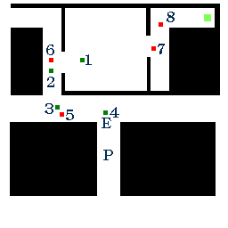

Waypoint key/values
Waypoints will have these keys:

- targetname – name of this waypoint
- target – name of the next waypoint along the path
- wait – monster should wait this amount of time at this waypoint. Useful for lifts.

And this spawnflag:

- retreat

If the “retreat” spawnflag is not set, the waypoint is assumed to be an attack waypoint.

Monster key/values
A waypointed monster has two new keys:

- Attack – name of the first waypoint on the attack path.
- Retreat – name of the first waypoint on the retreat path.

Issues
- Too many new edicts? Is there a way to do this without overloading a level with waypoints?
- Should the enemy “let go” of his waypoints to follow the player in the normal way? Under what conditions might this occur?
- Should an enemy whose health has been restored go back to his attack waypoint path to seek the player out again? Or is that set of waypoints no longer useful, now that the player probably has penetrated the map past the final waypoint spot. Should the enemy revert to the normal “hunt the player” mode?
- Is a waypoint path dedicated to a certain enemy? Does each enemy have to have separate attack and retreat paths? If not, certain “sharing” issues arise.
- The enemy’s fighting the player and has moved off his final attack waypoint. His health goes low and he looks for his first retreat waypoint. His beeline path to that waypoint is blocked (player, wall). How does he make that move? Should he strafe until he has a good line-of-sight to his waypoint? Should he bumble around?
- Are we limited to flat floors and stairs along a waypoint path? What about lifts? What about leaps off of balconies to floors below? What about water? What about teleporters?

Future Work
- Fork in the Road – the enemy could have a fork in his waypoint path. Two or more ways to reach his destination.
- Several retreat paths – the enemy could have several retreat paths to choose from.
- Pre-path the map. Give the enemy more intelligence to understand his map. More like a bot. Let him decide the best path to get to the player, or to get away from the player. Let him decide to let the player come to him.
- We can make the enemy smart enough to look for health jellies or some other means by which he can repair himself. Perhaps—like the jellies—we can allow him to slowly bring his health back to normal simply by staying away from the player. The enemy can also have some randomness. He might not always retreat. He might decide to retreat at varying health levels.

